DESIGN TABLES FOR PRODUCT AND CATEGORY ENTITIES.
Project Title: E-Commerce Order Management Database System

Project Title : E-Commerce Order Management Database System
Student Name : Yoga Moorthy S
Register Number : C4S38011
Department : B.Sc
Course : Artificial intelligence (AI)
Academic Year : 2026 – 2027

DBMS Practical - Product and Category Module
E-Commerce Order Management Database System

Design Tables

CREATE DATABASE ECommerceDB;
USE ECommerceDB;
CREATE TABLE Category (
CategoryID INT PRIMARY KEY,
CategoryName VARCHAR(100) NOT NULL
);
CREATE TABLE Product (
ProductID INT PRIMARY KEY,
ProductName VARCHAR(100) NOT NULL,
CategoryID INT,
Price DECIMAL(10,2),
Stock INT,
FOREIGN KEY (CategoryID) REFERENCES Category(CategoryID)
);
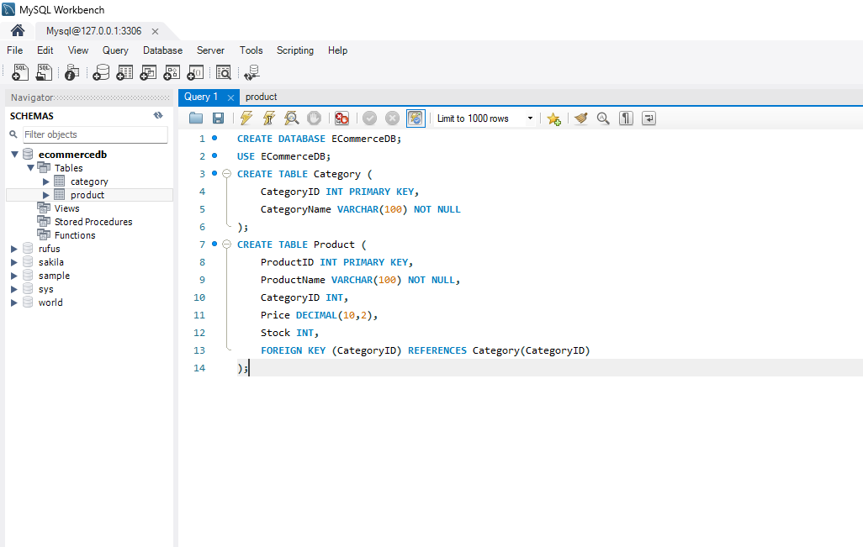

Primary and Foreign Keys

Primary Key
- CategoryID → Primary Key of Category table.
- ProductID → Primary Key of Product table.

Foreign Key
- CategoryID in Product table references CategoryID in Category table.

3. Insert Records
INSERT INTO Category VALUES
(1, 'Electronics'),
(2, 'Clothing'),
(3, 'Home Appliances');
INSERT INTO Product VALUES
(101, 'Laptop', 1, 55000.00, 20),
(102, 'Smartphone', 1, 25000.00, 50),
(103, 'T-Shirt', 2, 799.00, 100),
(104, 'Refrigerator', 3, 32000.00, 10),
(105, 'Washing Machine', 3, 28000.00, 15);

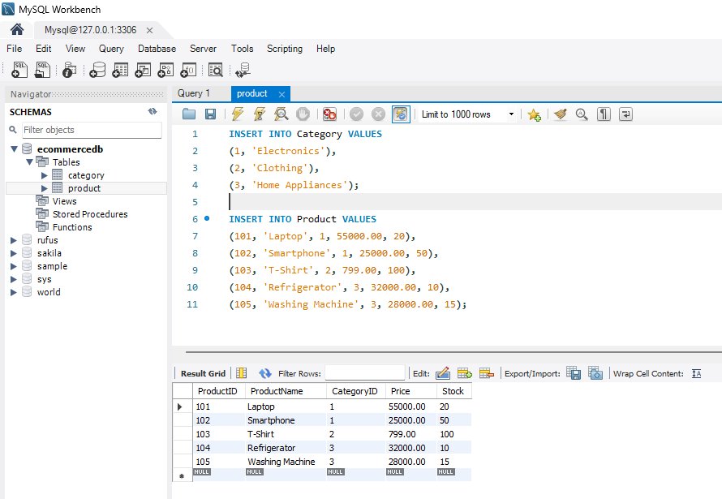

4. Insert, Update and Delete
INSERT INTO Product
VALUES (106, 'Headphones', 1, 2500.00, 40);

UPDATE Product
SET Price = 2300.00,
Stock = 45
WHERE ProductID = 106;

DELETE FROM Product
WHERE ProductID = 106;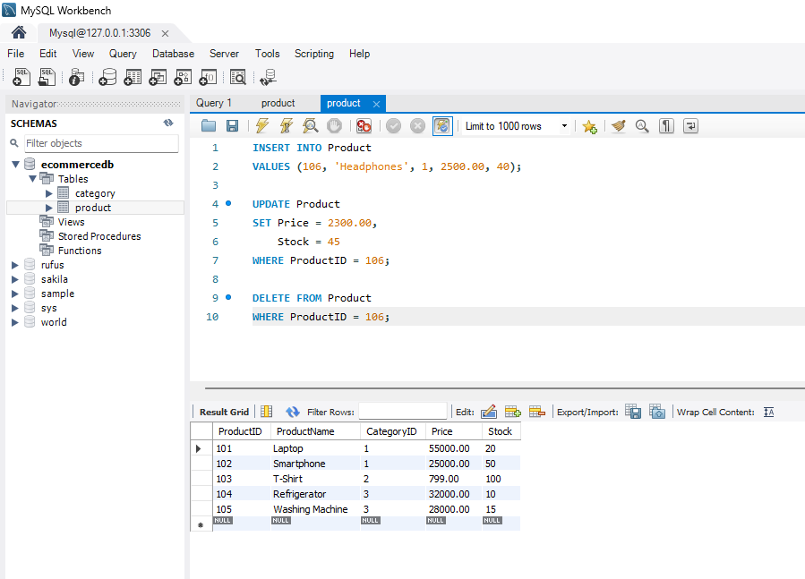

5. Category-wise Reports
SELECT
C.CategoryName,
P.ProductID,
P.ProductName,
P.Price,
P.Stock
FROM Product P
JOIN Category C
ON P.CategoryID = C.CategoryID
ORDER BY C.CategoryName;